Flow Name: Stop Service – Invoice Overdue Slack Notification

Problem:
Clients with unpaid invoices beyond an acceptable threshold need to be flagged for service suspension, but without automation this requires manual tracking across invoices and manual coordination between accounting and CSM teams. This increases the risk of delayed action and inconsistent enforcement.

Solution:
This automation monitors invoice and stop-service logs in Smartsheet, identifies clients with overdue invoices, records them in a stop-service log if not already present, and automatically notifies the relevant stakeholders in Slack to initiate service suspension.
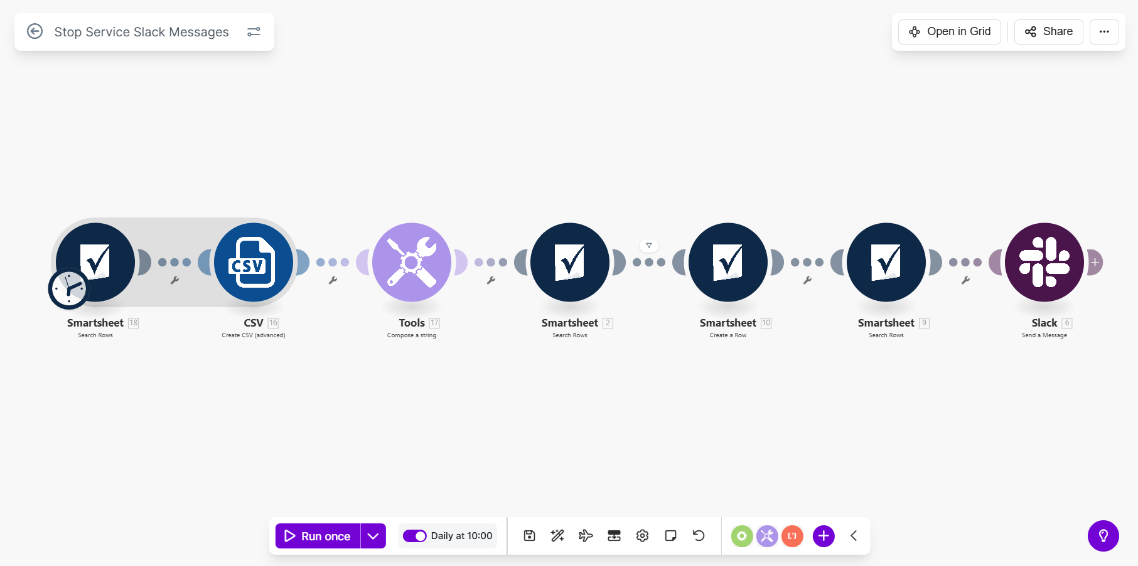
Flow Details:
Step 1: Load Existing Stop Service Records
The automation retrieves existing entries from the Stop Service Logs Smartsheet. The Client-Accounting Name column is used to identify which clients have already been logged for service suspension.
Step 2: Aggregate Existing Stop Service Client Names
All existing client accounting names from the Stop Service Logs sheet are aggregated into a single searchable text block. This aggregated dataset is used to prevent duplicate stop-service entries.
Step 3: Normalize Aggregated Stop Service Data
The aggregated text is normalized by removing line breaks and formatting characters, producing a clean comma-separated string suitable for containment checks.
Step 4: Load Overdue Invoice Records
The automation retrieves invoice rows from the Invoices Smartsheet where:
- Days invoice unpaid is greater than or equal to 30
- Group value is not equal to 1.1
This ensures only materially overdue invoices are considered.
Step 5: De-duplication Check Against Stop Service Logs
For each overdue invoice, the automation checks whether the client accounting name already exists in the Stop Service Logs aggregated dataset. If the client is already logged, the flow skips creation.
Step 6: Create Stop Service Log Entry
If the client does not already exist in the Stop Service Logs, a new row is created at the bottom of the Stop Service Logs sheet with the client’s accounting name. This establishes an auditable record of the stop-service decision.
Step 7: Load CSM Mapping Data
The automation retrieves the CSM Mappings Smartsheet to identify the Slack user ID associated with the client’s assigned CSM. This enables targeted Slack notifications.
Step 8: Post Stop Service Notification to Slack
A structured Slack message is posted in the private channel clients-automated-stop-service.
The message:
- Mentions the relevant internal stakeholder and the assigned CSM
- Identifies the affected client
- Clearly states that services should be paused due to invoices pending for 30 days or more
This message serves as the operational trigger for service suspension.

Overall Flow Summary:
This automation creates a controlled stop-service workflow by continuously monitoring overdue invoices, preventing duplicate stop-service records, and ensuring timely Slack notifications to the responsible teams. By using Smartsheet as the system of record and Slack as the action layer, the flow enforces consistent service suspension decisions while minimizing manual oversight.

